Hackathon: Gitcoin: 0) Setup A Local CKB Node And CKB Indexer For The Testnet

user name: Aryabhat

Github Repo: www.github.com/aryabhat1

email: sushant.pru@gmail.com

Completed the hackathon and the screenshots are as under:

1. CKB Node Screenshot:

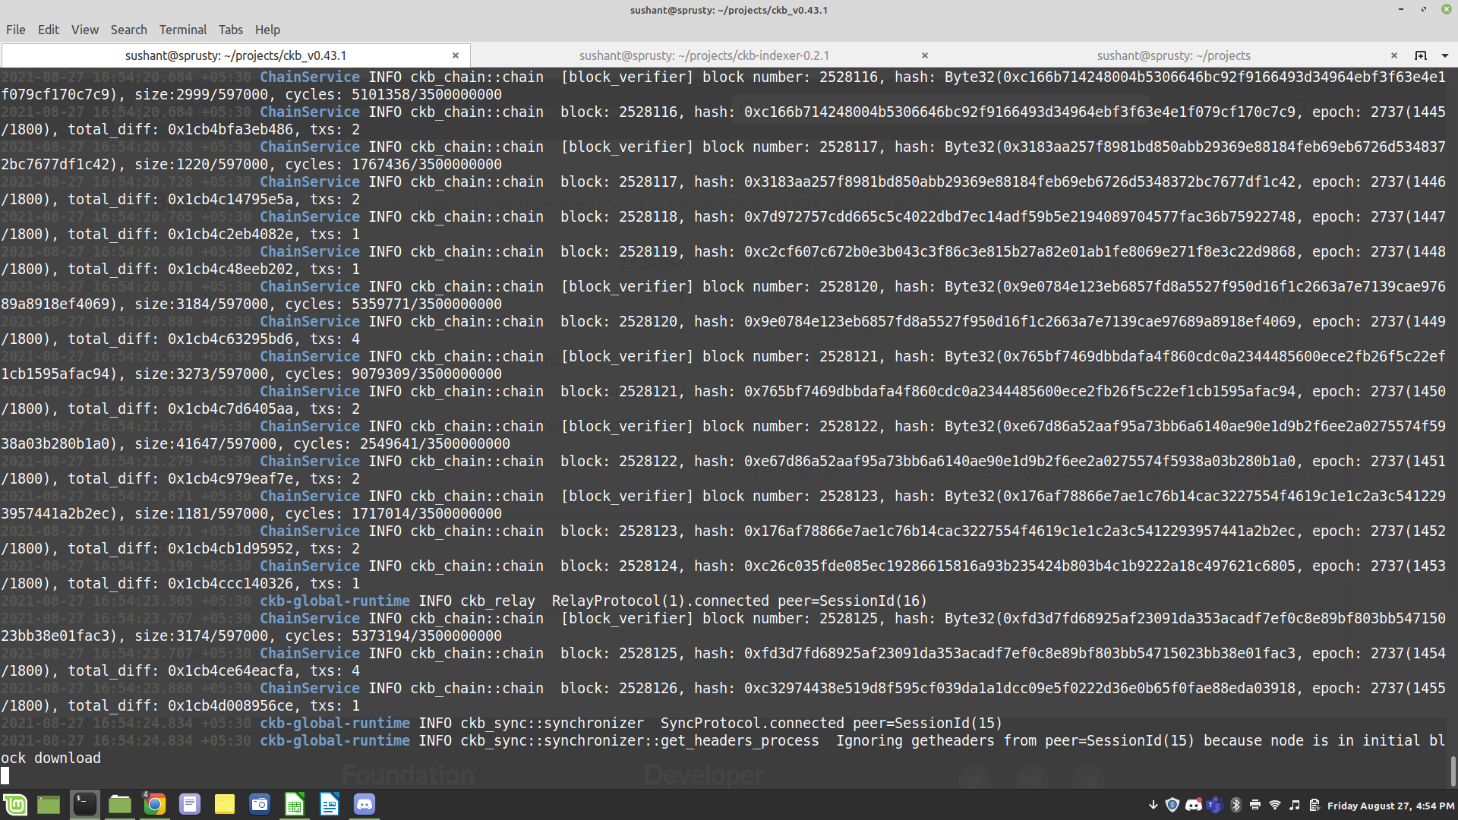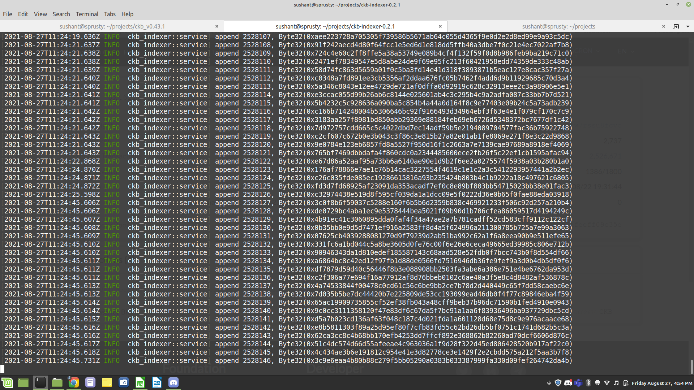====================================================

2. CKB Indexer:

3. Explorer to show synchronization:

